SCHOOL MANAGEMENT SYSTEM

**A PROJECT REPORT**

**Submitted to by**

**V.NIVETHA**

**M.PAVITHRA**

**M.SANGAMITHA**

**E.SARANPANDIYAN**

**S.VISHNU**

**Register Number: 35420U18006, 35420U18007, 35420U18008, 35420U18009, 35420U18010.**

***In Partial fulfillment of the requirements***

***For the award of the degree***

**Of**

**BACHELOR OF COMPUTER SCIENCE**



**DEPARTMENT FO COMPUTER SCIENCE**

**IMAYAM ARTS AND SCIENCE COLLEGE,**

**VANIYAMBADI**

**THIRUVALLUVAR UNIVERSITY VELLORE 632 115**

**2023**

**THIRUVALLUVAR UNIVERSITY**

**VELLORE**

**IMAYAM ARTS AND SCIENCE COLLEGE** **VANIYAMBADI**



# BONAFIDE CERTIFICATE

Certified that this Report titled **“School management System”** is the bonfire work of **V.NIVETHA (35420U18006), M.PAVITHRA (35420U18007), M.SANGAMITHA (35420U18008), E.SARANPNDIYAN (35420U18009), and S.VISHNU (35420U1810)** who carried out the work under my supervision. Certified further that to the best of my knowledge the work reported here in does not form part of any other thesis or dissertation on the basis of which a degree or award was conferred on an earlier occasion on this or any other candidate.

|  |  |
| --- | --- |
| **Signature of Internal Guide** | **Signature of HOD** |
| **Mr. K.VENUGOPAL, MCA.**  Assistant Professor,  Department of Computer Application,  Imayam Arts and Science College, Vaniyambadi – 635 751. | **Mr.G.ARIVAZHAGAN, MCA, M.Phil, B.ED.**  Associate Professor & HOD,  Department of Computer Science, Imayam Arts and Science College, Vaniyambadi – 635 751. |

Submitted to Project and viva examination held on at

Imayam Arts and Science College, Vaniyambadi – 635 751

**Internal Examiner External Examiner**

**CERTIFICATE OF EVALUATION**

|  |  |  |  |
| --- | --- | --- | --- |
| **COLLEGE NAME** | **:** 354, IMAYAM ARTS AND SCIENCE COLLEGE VANIYAMBADI. | | |
| **BRANCH & NAME** | **:** B.SC COMPUTER SCIENCE, 6th SEMESTER | | |
| **SUB.CODE & NAME** | **:** CPCS68, PROJECT WORK | | |
| **MONTH & YEAR** | **:**  2023 | | |
| Name of the Student who have Done the Project | Register  Number | Title of the Project | Name of the Supervisor With Designation | |
| **V.NIVETHA**  **M. PAVITHRA**  **M.SANGAMITHA**  **E.SARANPANDIYAN**  **S.VISHNU** | **35420U18006**  **35420U18007**  **35420U18008**  **35420U18009**  **35420U18010** | **SCHOOL MANAGEMENT SYSTEM** | **Mr.K.VENUGOPAL,**  **MCA. Assistant Professor,**  **Department of BCA** | |

The reports of the Project work submitted for the fulfillment of Bachelor of Computer Science of Thiruvalluvar University was evaluated and confirmed to be reports of the work done by the above student.

|  |  |  |
| --- | --- | --- |
| **Signature of Internal Guide** |  | **Signature of HOD** |

**Mr. K.VENUGOPAL, MCA. Mr.G.ARIVAZHAGAN, MCA, M.Phil, B.ED.**

Assistant Professor, Associate Professor & HOD,

Department of Computer Application, Department of Computer Science

Imayam Arts and Science College, Imayam Arts and Science College,

Vaniyambadi – 635 751. Vaniyambadi – 635 751.

**ABSTRACT**

This school management system project in PHP focuses mainly on dealing with students and teachers regarding their pieces of information, attendance, course, and other information. Also, the system displays all the available data such as total students, staff, teachers, attendance, payment, etc. The project is divided into five categories: Admin, Student, Teacher, Staff, and Parents Login. The admin has full control of the system, Admin can manage student’s, teacher’s, staff’s, parent’s accounts. Also, he/she can process payments of student fees. In terms of course and exam schedules, the user has to fill up various details in order to add a course by assigning a particular teacher. Later, the user can set up an exam schedule with the help of course ID, date, year, and time. All the reports, as well as the attendance sheet, can also be seen by the admin account. After entering for attendance of a particular teacher or staff, the system displays his/her records under the attendance section with a date. The admin can update teachers’ and staff’s salaries. Besides, the system also provides a feature to register parent’s accounts of each and every student. Under all these records, the user has to provide a photo of the identity of the students as well as teachers and staff.

**ACKNOWLEDGEMENT**

At the very outset, we wish to express my sincere thanks to all those who were involved in the completion of this project.

My most sincere salutations go to **THIRUVALLUVAR UNIVERSITY** that gave me an opportunity to have sound base of Computer Science.

We thank **Dr. . M.E., Ph.D., FIE,** Principal of Imayam Arts and Science College for permitting me to accomplish this project.

We offer my sincere thanks to **Mr. S.ARIVAZHAGAN, MCA, M.Phil, B.ED,** Head of the Department of Computer Science for giving this opportunity and his full encouragement.

We consider it as a great privilege to place a record of our deep sense of gratitude to our Internal Guide **Mr.K.VENUGOPAL, MCA** Assistant Professor Department of Computer Applications.

I also express my thanks to **Our Faculty Members and my friends.**

**V.NIVETHA**

**M.PAVITHRA**

**M.SANGAMITHA**

**E.SARANPANDIYAN**

**S.VISHNU**

**TABLE OF CONTENTS**

|  |  |  |
| --- | --- | --- |
| **CHAPTER NO.** | **TITLE** | **PAGE NO.** |
|  | **ABSTRACT** | i |
|  | **LIST OF TABLES** | vii |
|  | **LIST OF FIGURES** | viii |
| 1 | **INTRODUCTION** | 1 |
|  | 1.1 Objectives Of The System | 1 |
|  | 1.2 About The Project | 1 |
| 2 | **COMPANY PROFILE**  2.1 About The Company | 3  3 |
| 3 | **SYSTEM ANALYSIS** | 4  4 |
|  | 3.1 Existing System |
|  | 4 |
|  | * 1. Proposed System   2. Methodology | 5 |
| 4 | **SYSTEM CONFIGURATION** | 8  8 |
|  | 4.1 Hardware Configuration | 8 |
|  | * 1. Software Configuration   2. Software Description | 9 |

v

## TABLE OF CONTENTS

|  |  |  |
| --- | --- | --- |
| **CHAPTER NO.** | **TITLE** | **PAGE NO.** |
| 5 | **SYSTEM DESIGN** | **12** |
|  | 5.1 Architecture Diagram | 12 |
|  | 5.2 ER Diagram | 13 |
|  | 5.3 Data Flow Diagram | 14 |
|  | 5.4 UML Diagram | 15 |
|  | 5.4.1 Use Case Diagram | 15 |
|  | 5.4.2 Class Diagram | 16 |
|  | 5.4.3 Activity Diagram | 17 |
|  | 5.4.4 Sequence Diagram | 18 |
| 6 | **PROJECT DESCRIPTION** | 26 |
|  | 6.1 Problem Definition | 26 |
|  | 6.2 Module Description | 27 |
| 7 | **SOFTWARE TESTING & MAINTENANCE** | 28 |
|  | 7.1 System Testing | 28 |
|  | 7.2 Types Of Testing | 28 |
|  | 7.2.1 Unit Testing | 28 |
|  | 7.2.2 Integration Testing | 29 |
|  | 7.2.3 Validation Testing | 29 |
|  | 7.2.4 Output Testing | 29 |
|  | 7.2.5 Acceptance Testing | 29 |

**TABLE OF CONTENTS**

|  |  |  |
| --- | --- | --- |
| **CHAPTER NO.** | **TITLE** | **PAGE NO.** |
| 8 | **TEST CASES** |  |
| 9 | **CONCLUTION** |  |
|  | **FURTHER ENHANCEMENT** |  |
| 10 | **APPENDICES** |  |
|  | 10.1 Sample Codes |  |
|  | 10.2 Screen Shots |  |
| 11 | **REFERENCES** |  |

## LIST OF TABLES

|  |  |  |
| --- | --- | --- |
| **TABLES NO.** | **TITLE** | **PAGE NO.** |
| 5.5  5.5.1 | DATABASE DESIGN  ATTENDANCE | 19  20 |
| 5.5.2  5.5.3  5.5.4  5.5.5  5.5.6  5.5.7  5.5.8  5.5.9  5.5.10  5.5.11  5.5.12  5.5.13  5.5.14 | AVAILABLE COURSE CLASS  COURSE  EXAM SCHEDULE GRADE  PARENTS PAYMENT REPORT STAFF STUDENT STUDENT TEACHER USER | 20  20  21  21  21  22  22  23  23  24  24  25  25 |

‘

## LIST OF FIGURES

|  |  |  |
| --- | --- | --- |
| **FIGURES NO.** | **TITLE** | **PAGE NO.** |
| 3.4.1 | SPIRAL MODEL DIAGRAM | 5 |
| 5.1 | ARCHITECTURAL DIAGRAM | 12 |
| 5.2 | ER DIAGRAM | 13 |
| 5.3 | DATA FLOW DIAGRAM | 14 |
| 5.4.1 | USE CASE DIAGRAM | 15 |
| 5.4.2 | CLASS DIAGRAM | 15 |
| 5.4.3 | ACTIVITY DIAGRAM | 17 |
| 5.4.4 | SEQUENCE DIAGRAM | 18 |

**CHAPTER 1 INTRODUCTION**

* 1. **Objective of The System**

This project is developed for school management system. It is a software package developed for student details, staff details and school details. The software is very helpful for school. The system provides information on the past, present and future and on relevant events inside and outside the organization. It may be defined as a planned and integrated system for gathering relevant data, converting it in to right information and supplying the same to the concerned executives. The main purpose of management system is to provide the right information to the right person at the right

## About The Project

The project “SCHOOL MANAGEMENT SYSTEM” aims at collecting information about the school details. The project work is to retain information of all the details in school. This software used to easily manage the process and access the information. List such as teachers, student details and cover all important facts as reading reports.

* + - To provide student detailed information and faculty details.
    - To make admission procedure fast and easy.
    - To inform student with time to time event information and notices.
    - To generate separate student and faculty login Id and password.

## Teacher Panel

After logging in as a teacher, the user can manage a particular student’s grade by selecting class, course, and student’s name. Under the courses section, the system displays all the available courses for that particular teacher. The teacher has to manage all his student’s attendance by selecting classes and courses. Also, the teacher can view his/her salary reports, attendance sheets as well. Besides, the teacher account has the ability to create a student’s overall report stating about his student’s progress. For easiness and time saving, he/she can simply search for his student’s information using the student’s id or name.

**Student and Parents Panel**

Under the student section, the student can view his/her course and results which displays the result with the teacher’s ID, name, email, section, classroom, and grades. Rather than these, the student can only view upcoming exam schedules and attendance sheets. Talking about the Parents panel, the user can simply view his/her children’s information as well as course and results. The parents can also submit their children’s payments from the child payments section. The parents can also look for their children’s reports for tir overall progress status and attendance sheets.

**Staff Panel**

On the other hand, the system allows staff accounts to update their account information, view his/her salary statements and check attendance sheets too. Under the salary section, it displays a particular staff’s monthly salary with payable salary for the month which is calculated after his/her attendance record. From the attendance section, the system shows the attendance of the current month with absent dates. Amongst all of the accounts, the staff account has the minimum feature.

## CHAPTER 2 ORGANIZATION PROFILE

**2.1 About The Company**

# CHAPTER 3

## SYSTEM ANALYSIS

* 1. **Existing System**

The existing system is fully based on manual work. In olden day staffs are maintain the student details and school details in record. It involves heavy paper work. It also leads to data redundancy. So many draw back are available.

Limitations

* + - Time is increased .
    - Error may occur.
    - No security of data.
    - Mistake occurring in long calculation
    - Not proper generation report.
    - Inability to produce timely report to management.
    - A lot of file work had to be done for storing information like student details, faculty details.
    - There may be possibility of delay in managing whole admission process.
    - Also certain information redundancy may occur then it will become a hurdle to manage.
    - Staff member Management entitles all management of activities related to notice, time table and result publish and so on requires a lot of paper work.
  1. **Proposed System**

The proposed system aim is to remove most of the drawback found extensively in the existing system. The proposed computerization is developed using PHP and MySQL as back end and most powerful HTML and Java Script as front end .It can be though that easy maintenance, faster development of performances, and easy usage of data in proposed system.

ADVANTAGES

* + - Time reduce
    - The details about the school information are showed.
    - Keep maintenance of data easily with help of database.
    - computing process only.
    - To see reports quickly.
    - Relevant details pertaining to students and school willing to Know is details can do so by accessing by the user.
    - The proposed website controls student information and faculty details.
    - This is web based project it’s provide privilege facility for security purpose and provide login facility according to designation and restrict unauthorized used, if user is not admin then it can’t access everything, this project provide four type of designation facility and access permission.
    - We can generate report according to date & show all report also; Because of manual system we faced many problems. The maintenance cost of manual system was very high. And they didn’t store historical information and not possible to view all at a time.

**3.3 Methodology**

## Spiral Model

Spiral model in software testing is the testing strategy which works on incremental and prototype technique. Generally spiral model strategy is followed for the large and complicated projects where risks are high and development and testing goes on incremental basis. Spiral model is also known as spiral lifecycle model. The spiral model was introduced by Barry Boehm in 1985.this model is quite old but still very useful for the largeprojects development and testing.

They are five phases in spiral model

* + - Planning of each phase and next phase.
    - Risk analysis
    - Engineering
    - Execution
    - Evolution

## 3.3.1 Spiral Model Diagram

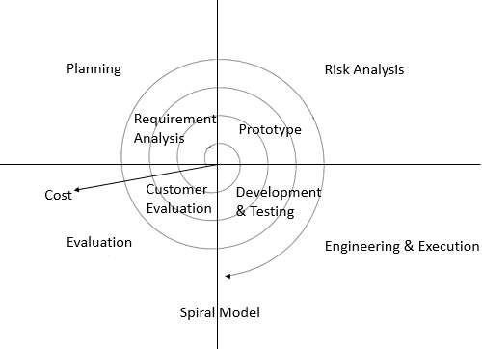

Fig; spiral model

Testing and development starts from planning phase and carries up to evaluation phase. All the requirement is collected in the planning phase it self.in the risk analysis phase we assume all the risks could be occurred during testing and development .in engineering and execution.

All the possible requirements of the system to be developed are captured in thisphase and documented in a requirement specification doc. that is called as analysis.

## DESIGN

The requirement specification from first phase are studied in this phase and system is prepared. system design in specifying hardware and system requirementsand also helps in defining overall system architecture.

## Coding

With inputs from system design, the system is first developed in small Programs called units, which are integrated in the next phase. each unit is developed and tested its functionality which is referred to as unit testing.

## Testing

All the units developed in the implementation phase are integrated system after testing of each unit. post integration the entire system is tested for any faultsa failure.

## Maintenance

There is some issues which come up in the client environment .to fix thoseissues patches are released.

## Feasibility Study

The feasibility of the project is analysed in this phase and business proposalis put forth with a very general plan for the project and some cost estimate. during system analysis the feasibility study of the proposed system is to be carried out. Thisis ensuring that the proposed system is not a burden to the company.

Three keys considerations involved in the feasibility analysis are

* Economical feasibility
* Technical feasibility
* social feasibility

## Economic Feasibility

A system can be developed technically and that will be used if installed must still be a good investment for the organization .in the economical feasibility ,the development cost in creating the system is evaluated against the ultimate benefitderived from a new system.

## Technical Feasibility

The technical issues usually raised during the feasibility stage of the investigation includes the followings:

* Does the necessary technology exists to do what is suggested
* Do the proposed equipment have the technical capacity
* Try to hold the data required to use the new system
* Will the proposed system provide acquired response
* Can the system be upgraded if

developed

## Social Feasibility

Social feasibility is one of the feasibility study where the acceptance of the people is considered regarding the product to be launched. It describes the effect on users from the introduction of the new system considering whether there will be a need for retraining the workforce where the acceptance of the people is considered regarding the product to be launched.

# CHAPTER 4 SYSTEM CONFIGURATION

## Hardware Configuration

RAM : 4 GB

HDD : 500 GB

PROCESSOR : Intel core i3

## Software Configuration

Front End : Html

Back End : Laravel Web Frame Work & MySQL Script : PHP

Operating System : Windows 10

## Software Description

* + 1. **Front End**

Active server page (MYSQL), also known as classic MYSQL, was introduced in 1998 as Microsoft first server side scripting engine. MYSQL is a technology that enable scripts in web pages to be executed by an internet server MYSQL pages have the file extension.asp,are normally written in VB (visual Basic) script.

## PHP

PHP (PERSONAL HOME PAGE) code may be embedded into HTML or HTML5 markup, or it can be used in combination with various web template systems, web content management systems and web frameworks. PHP code is usually executed PHP code,which may be any type of data, including images, with the generated web pags .. PHP code may also be executed with a command-line interface (CLI) and can be used to iplementstand alone graphical applications. The standard PHP intreprete,poweredbu the zend engine, is free software released under the PHP license PHP has been widely ported and can be deployed on most web servers on almost every operating system and platform,free of charge

The PHP language evolved without a written formal specification or standard until2014,leaving the canonical PHP interpreter as a de facto standard. since 2014 work has gone on to create a formal PHP specification

## HTML

Hypertexter markup language commenly referred to as HTML, is the standard markup language used to create web pages. it's written the form of HTML elements consistings of tags enclosed in angle brackets (like<html>HTML tags most commonly come in pairs like <hl>and </hl>, although some represent empty elements and so are unpaired for example <img>.the first tag in such a pair is start tag.and the second in the end tag.

## Back End

MYSQL is the world's second most widely used relational database management system (RDBMS) and most widely used open source RDBMS.It's named after co- founder Michaeldaughter. MYSQL acronym stands for structure query language.

The MYSQL development project has made its source code available under the terms of the GNU general pubic license, as well under a variety of proprietary agreement

## MYSQL

Php is a programing framework build on the common language run time that can beused on a server to build powerful web application. php offers several important advantages over previous web development models.

Enhanced performance:

prossed by a PHP interpreter implemented as a module in the web server or as a common gateway interface (CGI) executable. The web server software combines the results of the interpreted and

Php is compiled common language runtime code running on the server. unlike its interpreted predecessors. php can take advantage of early binding. Just in time compilationnative optimization and catching service right of the box.

Security:

With the build in windows authentication and per application configuration you canbe assured that you application secure.

Crystal reports:

Crystal reports for virtual basic php is the standard reporting tool for virtual basic pip it brings the ability to create presentation quality content which has been

.net you can host the report on web application on crystal report on web server.

## About Microsoft Sql Server 2008

Microsoft sql server is a structure query language sql based client/server relational database. Each of these terms describes a fundamental part of the architecture of aql server.

# Database

A database is similar to a data file in that is storage for data. like a data file, a database does not present information directly to a user runs an application that accesses data from database and present in to the user in the understandable format. Relational database their different ways to organize in a database but relational database are one of the most effective. relational database system is an application of mathematical set of theory of the problem of efficiency organizing data. A database in Microsoft sql server consists of tables that contain data and other objects, such as views, indexes, stored procedures, and triggers defined to support activities performed with the data.

## E-R DIAGRAM

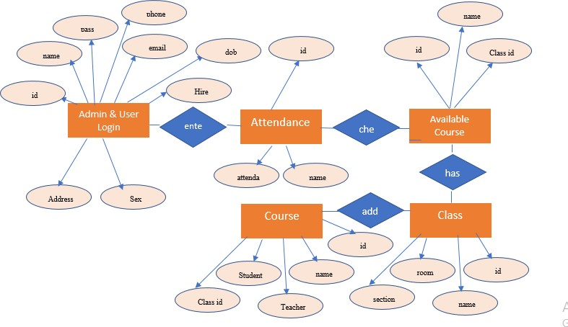

**Figure No: 5.2 E-R Diagram**

## DATA FLOW DIAGRAM

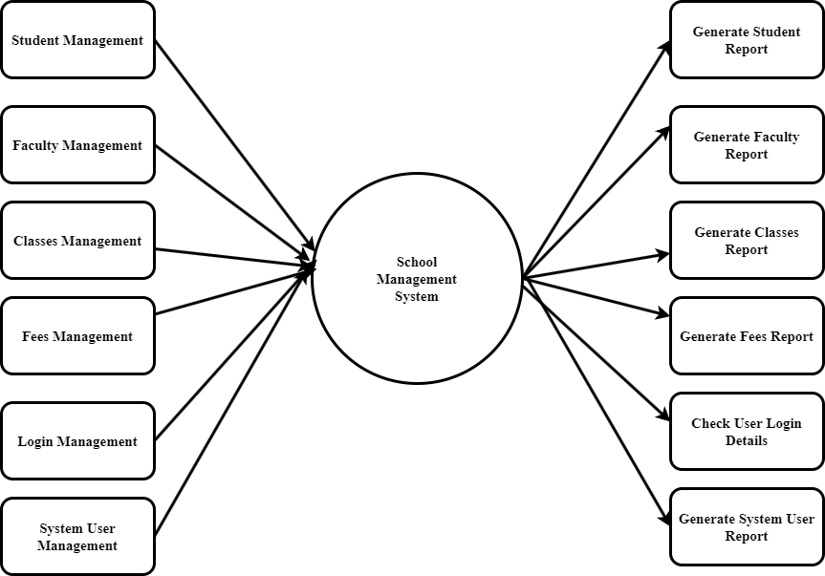

**Figure : Level 0**

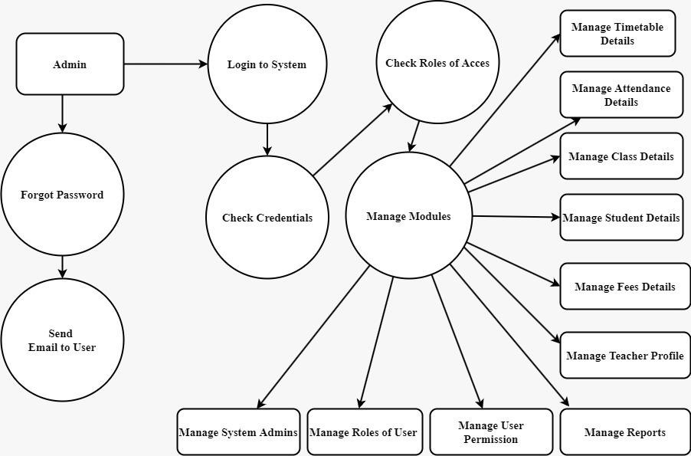

## Figure : Level 1

**5.4. UML DIAGRAM**

## Use case diagram

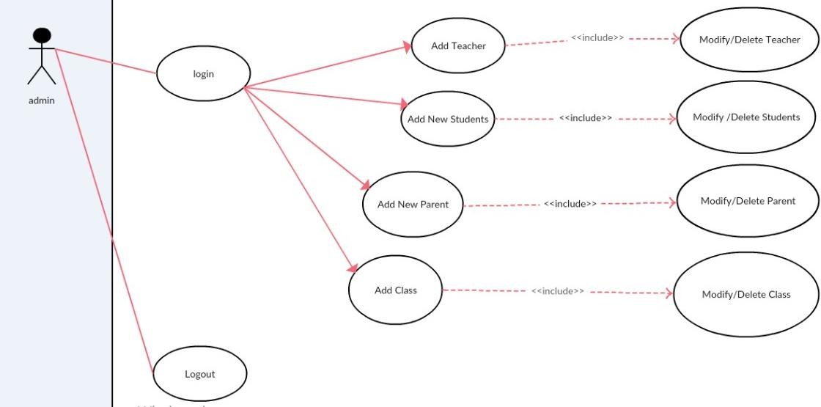

**Figure 5.4.1.1 Admin use case Diagram**

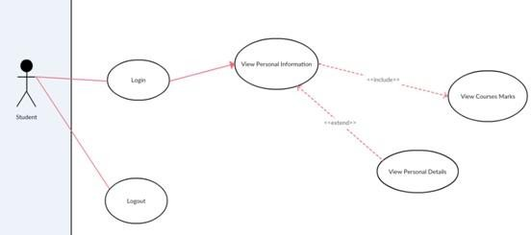

## Figure 5.4.1.2 Student use case Diagram

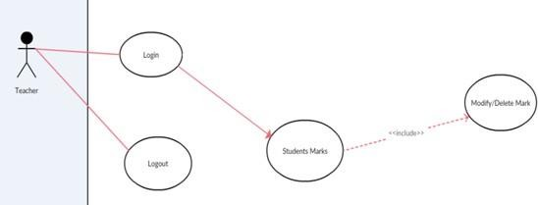

**Figure 5.4.1.3 : Teacher use case Diagram**

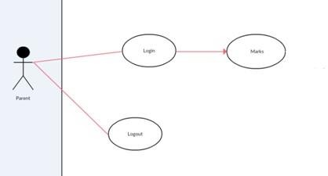

## Figure 5.4.1.4 : Parent use case Diagram

* + 1. **Class Diagram**

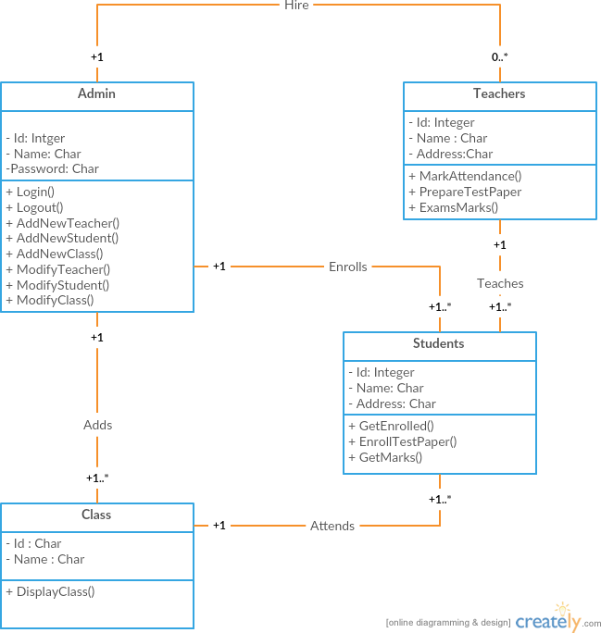

## Figure 5.4.2 : Class Diagram

* + 1. **Activity Diagram**

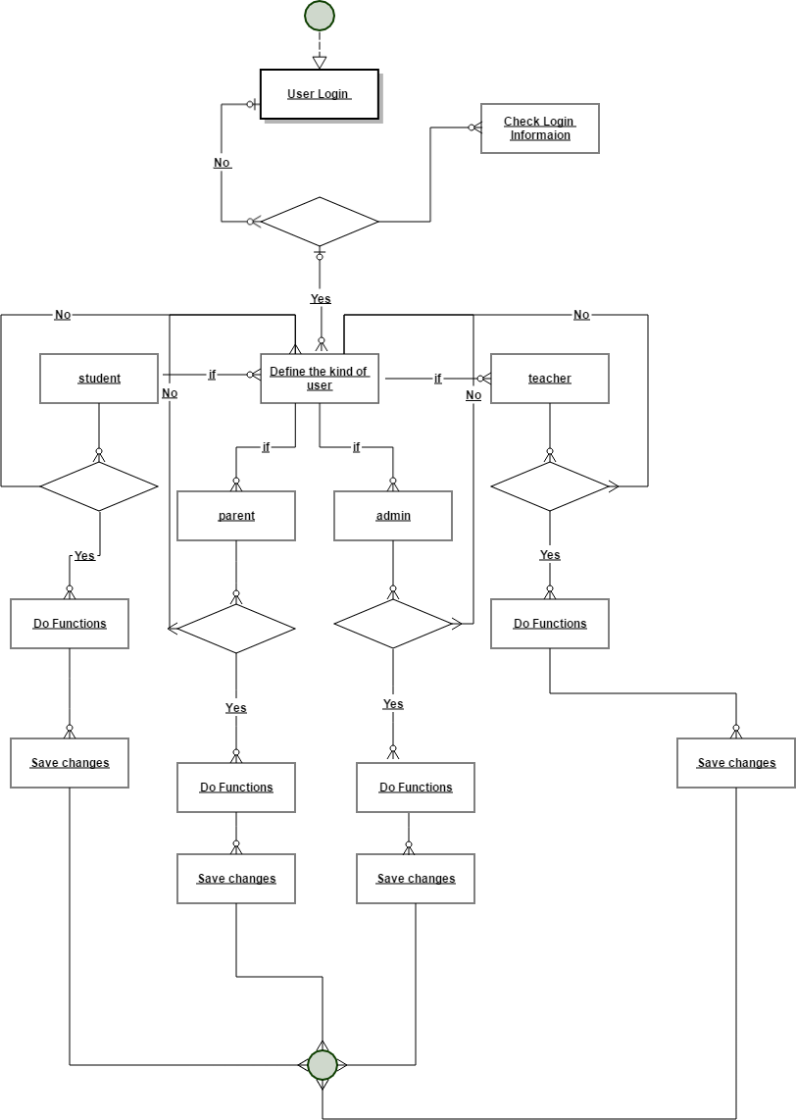

## Figure 5.4.3 : Activity Diagram

**5.4.4. Sequence Diagram**

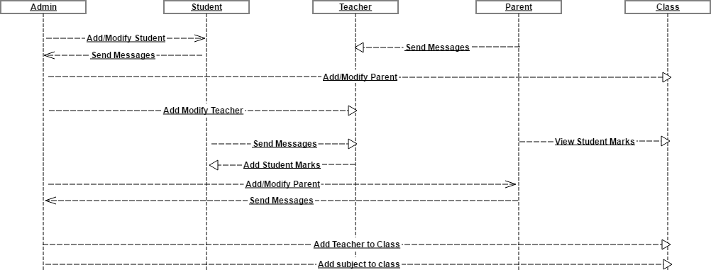

## Figure 5.4.4 : Sequence Diagram

* 1. **Data base Design**

Table No.: #1

Table Name: Admin & User Login

In this table information about user and password of the admin are stored in a database

|  |  |  |  |  |  |
| --- | --- | --- | --- | --- | --- |
| S.No | Field name | Data Type | Size | Constrain | Description |
| 01 | Admin_ Id | Int | 18 | Not Null | Enter Id |
| 02 | name | Varchar | 18 | Not Null | Enter name |
| 03 | password | Varchar | 12 | Not Null | Enter password |
| 04 | Phone | Varchar | 20 | Not Null | Enter phone number |
| 05 | email | Varchar | 20 | Not Null | Enter email |
| 06 | dob | date | date | Not Null | Enter date of birth |
| 07 | Hire_ date | Date | date | Not Null | Enter date of hire |
| 08 | address | Varchar | 20 | Not Null | Enter address |
| 09 | sex | Varchar | 20 | Not Null | Enter sex |

Table No.: #2

## Table Name: Attendance

|  |  |  |  |  |  |
| --- | --- | --- | --- | --- | --- |
| S.No | Field name | Data Type | Size | Constrain | Description |
| 01 | Id | Int | 11 | Not Null | Enter id |
| 02 | Date | date | date | Not Null | Enter date |
| 03 | attendance | varchar | 20 | Not Null | Enter attendance |

Table No.: #3

## Table Name: Available Course

|  |  |  |  |  |  |
| --- | --- | --- | --- | --- | --- |
| S.No | Field name | Data Type | Size | Constrain | Description |
| 01 | Id | Int | 11 | Not Null | Enter id |
| 02 | Name | Varchar | 30 | Not Null | Enter name |
| 03 | Class_id | varchar | 30 | Not Null | Enter class id |

Table No.: #4

## Table Name: Class

|  |  |  |  |  |  |
| --- | --- | --- | --- | --- | --- |
| S.No | Field name | Data Type | Size | Constrain | Description |
| 01 | Id | Varchar | 20 | Not Null | Enter id |
| 02 | Name | Varchar | 20 | Not Null | Enter name |
| 03 | Room | varchar | 20 | Not Null | Enter class id |
| 04 | section | Varchar | 20 |  |  |

Table No.: #5

## Table Name: Course

|  |  |  |  |  |  |
| --- | --- | --- | --- | --- | --- |
| S.No | Field name | Data Type | Size | Constrain | Description |
| 01 | id | Varchar | 20 | Not Null | Enter id |
| 02 | name | Varchar | 20 | Not Null | Enter name |
| 03 | teacher_id | varchar | 20 | Not Null | Enter teacher id |
| 04 | student_id | Varchar | 20 | Not Null | Enter student id |
| 05 | classid | Varchar | 20 | Not Null | Enter class id |

Table No.: #6

## Table Name: Exam Schedule

|  |  |  |  |  |  |
| --- | --- | --- | --- | --- | --- |
| S.No | Field name | Data Type | Size | Constrain | Description |
| 01 | id | Varchar | 20 | Not Null | Enter id |
| 02 | examdate | Date | date | Not Null | Enter examdate |
| 03 | time | Time | time | Not Null | Enter time |
| 04 | Courseid | Varchar | 20 | Not Null | Enter course id |

Table No.: #7

## Table Name: Grade

|  |  |  |  |  |  |
| --- | --- | --- | --- | --- | --- |
| S.No | Field name | Data Type | Size | Constrain | Description |
| 01 | id | int | 20 | Not Null | Enter id |
| 02 | Studentid | Varchar | 20 | Not Null | Enter student id |
| 03 | grade | Varchar | 20 | Not Null | Enter grade |
| 04 | Courseid | Varchar | 20 | Not Null | Enter course id |

Table No.: #8

## Table Name: Parents

|  |  |  |  |  |  |
| --- | --- | --- | --- | --- | --- |
| S.No | Field name | Data Type | Size | Constrain | Description |
| 01 | id | Varchar | 20 | Not Null | Enter id |
| 02 | password | Varchar | 20 | Not Null | Enter password |
| 03 | Fathername | Varchar | 20 | Not Null | Enter father name |
| 04 | Mothername | Varchar | 20 | Not Null | Enter mother name |
| 05 | Fatherphone | Varchar | 20 | Not Null | Enter father phone no |
| 06 | Motherphone | Varchar | 20 | Not Null | Enter mother phone no |
| 07 | address | Varchar | 20 | Not Null | Enter address |

Table No.: #9

## Table Name: Payment

|  |  |  |  |  |  |
| --- | --- | --- | --- | --- | --- |
| S.No | Field name | Data Type | Size | Constrain | Description |
| 01 | id | int | 20 | Not Null | Enter id |
| 02 | Studentid | Varchar | 20 | Not Null | Enter student id |
| 03 | Amount | Double | 20 | Not Null | Enter amount |
| 04 | month | Varchar | 20 | Not Null | Enter month |
| 05 | year | Varchar | 20 | Not Null | Enter year |

Table No.: #10

## Table Name: report

|  |  |  |  |  |  |
| --- | --- | --- | --- | --- | --- |
| S.No | Field name | Data Type | Size | Constrain | Description |
| 01 | Reportid | int | 20 | Not Null | Enter id |
| 02 | Studentid | Varchar | 20 | Not Null | Enter student id |
| 03 | teacherid | varchar | 20 | Not Null | Enter teacher id |
| 04 | message | Varchar | 20 | Not Null | Enter message |
| 05 | courseid | Varchar | 20 | Not Null | Enter course it |

Table No.: #11

## Table Name: staff

|  |  |  |  |  |  |
| --- | --- | --- | --- | --- | --- |
| S.No | Field name | Data Type | Size | Constrain | Description |
| 01 | Id | int | 20 | Not Null | Enter id |
| 02 | Name | Varchar | 20 | Not Null | Enter name |
| 03 | Password | varchar | 20 | Not Null | Enter password |
| 04 | Phone | Varchar | 20 | Not Null | Enter phone no |
| 05 | Email | Varchar | 20 | Not Null | Enter email id |
| 06 | Sex | Varchar | 20 | Not Null | Enter sed |
| 07 | Dob | date | date | Not Null | Enter date |
| 08 | Hiredate | date | date | Not Null | Enter hire date |
| 09 | Salary | double |  | Not Null | Enter salary |
| 10 | address | Varchar | 20 | Not Null | Enter address |

Table No.: #12

## Table Name: student

|  |  |  |  |  |  |
| --- | --- | --- | --- | --- | --- |
| S.No | Field name | Data Type | Size | Constrain | Description |
| 01 | Id | int | 20 | Not Null | Enter id |
| 02 | Name | Varchar | 20 | Not Null | Enter name |
| 03 | Password | varchar | 20 | Not Null | Enter password |
| 04 | Phone | Varchar | 20 | Not Null | Enter phone no |
| 05 | Email | Varchar | 20 | Not Null | Enter email id |
| 06 | Sex | Varchar | 20 | Not Null | Enter sed |
| 07 | Dob | date | date | Not Null | Enter date |
| 08 | Admission date | date | date | Not Null | Enter hire date |
| 09 | Address | Varchar | 20 | Not Null | Enter address |
| 10 | Parent id | Varchar | 20 | Not Null | Enter parent id |
| 11 | Class id | Varchar | 20 | Not Null | Enter class id |

Table No.: #13

## Table Name: student

|  |  |  |  |  |  |
| --- | --- | --- | --- | --- | --- |
| S.No | Field name | Data Type | Size | Constrain | Description |
| 01 | Id | int | 20 | Not Null | Enter id |
| 02 | Couseid | Varchar | 20 | Not Null | Enter course id |
| 03 | teacherid | varchar | 20 | Not Null | Enter teacher id |

Table No.: #14

## Table Name: teacher

|  |  |  |  |  |  |
| --- | --- | --- | --- | --- | --- |
| S.No | Field name | Data Type | Size | Constrain | Description |
| 01 | Id | int | 20 | Not Null | Enter id |
| 02 | Name | Varchar | 20 | Not Null | Enter name |
| 03 | Password | varchar | 20 | Not Null | Enter password |
| 04 | Phone | Varchar | 20 | Not Null | Enter phone no |
| 05 | Email | Varchar | 20 | Not Null | Enter email id |
| 06 | Sex | Varchar | 20 | Not Null | Enter sed |
| 07 | Dob | date | date | Not Null | Enter date |
| 08 | Hiredate | date | date | Not Null | Enter hire date |
| 09 | Salary | double |  | Not Null | Enter salary |
| 10 | address | Varchar | 20 | Not Null | Enter address |

Table No.: #15

* + 1. **Table Name: user**

|  |  |  |  |  |  |
| --- | --- | --- | --- | --- | --- |
| S.No | Field name | Data Type | Size | Constrain | Description |
| 01 | Userid | Varchar | 20 | Not Null | Enter id |
| 02 | password | Varchar | 20 | Not Null | Enter password |
| 03 | usertype | varchar | 20 | Not Null | Enter usertype |

# CHAPTER 6

## PROJECT DESCRIPTION

* 1. **Problem Definition**

After logging in as a teacher, the user can manage a particular student’s grade by selecting class, course, and student’s name. Under the courses section, the system displays all the available courses for that particular teacher. The teacher has to manage all his student’s attendance by selecting classes and courses. Also, the teacher can view his/her salary reports, attendance sheets as well.

Under the student section, the student can view his/her course and results which displays the result with the teacher’s ID, name, email, section, classroom, and grades. Rather than these, the student can only view upcoming exam schedules and attendance sheets. Talking about the Parents panel, the user can simply view his/her children’s information as well as course and results.

## Module Description

**Admin**

The person in this module has control over the entire system as he/she can add, delete anyone from the system. The admin can view the details of another person and can edit any details. The users from another module will send the request to admin for any change.

## Students

From this module, the students can view the details of the assignment given to them, test date, results, time-table.

## Parents

The parents can monitor the performance of their children, can contact with the teachers, view the due fee amount.

## Faculty

This module contains the information of a teachers, librarian, accountant.

# CHAPTER 7

## SOFTWARE TESTING AND MAINTANENCE

* 1. **System Testing**

System testing is the stage of Implementation Which is aimed at ensuring that the system works accurately and efficiently before live operation commences. Testing is vitalto the success of the system. An elaborate testing of data is prepared and the system is tested using this data. While testing error noted and corrections are mode. The users are trained to operate the developed system. Both hardware and software securities are made to run the developed system successfully in future.

## Types of Testing

* + - Unit Testing
    - Integration Testing
    - Validation Testing
    - Output Testing
    - User Acceptance Testing

## Unit Testing

Unit testing focuses verification efforts on the smallest unit of software design, themodule. This is known as “Module Testing”. The modules are tested separately. This testing is carried out during programming stage itself. In this testing step each module is found to be working satisfactorily as regard to the expected output from the module.

## Integration Testing

Integration testing is a systematic technique for constructing tests to uncover errors associated with in the interface. In this project, all the module combined, and the entire program is tested as a whole. Thus in the integration testing step, all the errors uncovered are corrected for the text testing steps.

## Validation Testing

Validation Testing is where requirements established as a part of software requirement analysis is validated against the software that has been constructed. This test provides the final assurance that the software meets all functional, behavioral and performance requirements. The errors, which are uncovered during integration testing is corrected during this phase.

## Output Testing

After performing the validation testing, the next step is out testing of the proposed system since no system could be useful if it does not produce the required output in the specific format. The output generated or displayed by the system under consideration is tested asking the users about the format required by then. Here, the output is considered into two ways, one is on the screen and other is printed format. The output format on the screen is found to be correct as the format designed according to the user needs. For the hard copy also; the output comes out as specified by the user. Hence output comes out as specified by the user. Hence output texting doesn’t result in any connection in the system.

## User Acceptance Testing

User acceptance of a system is the key factor for the success of any system. The system under consideration is tested for user acceptance by constantly keeping in touch with the prospective system users at time developing and making for proxy server.

# CHAPTER 8

## TEST CASES

**Test Case ID:** 1 **Test Designed by: XXXXXX** **Test Priority (Low/Medium/High):** Med **Test Designed date:** 05-03-2024 **Module Name:** User Login **Test Executed by: xxxxxx**

**Test Title:** Verify login with valid username and password

**Description:** Test the user login page

**Test Execution date:** 06-03-2024

**Pre-conditions:** User has valid username and password

## Dependencies:

|  |  |  |  |  |  |  |
| --- | --- | --- | --- | --- | --- | --- |
| **Step** | **Test Steps** | **Test Data** | **Expected Result** | **Actual Result** | **Status (Pass/ Fail)** | **Notes** |
| 1 | Navigate to login page | Test username and password | User should be login | navigated  to dashboard | Pass |  |
| 2 | Provide  valid username | User name: [User@gmail.com](mailto:User@gmail.com) |  |  |  |  |
| 3 | Provide  valid password | Password: 123 |  |  |  |  |
| 4 | Click on Login button |  |  | navigated to dashboard successfully | pass |  |

**Post-conditions:**

User is validated with database and successfully login to account. The accountsession details are logged in database.

**Test Case ID:** 2 **Test Designed by: xxxxxx**

**Test Priority (Low/Medium/High):** Med **Test Designed date:** 05-03-2024 **Module Name:** admin Login **Test Executed by:** xxxxxx

**Test Title:** Verify login with valid username and password

**Description:** Test the user login page

**Test Execution date:** 05-03-2024

**Pre-conditions:** User has valid username and password

## Dependencies:

|  |  |  |  |  |  |  |
| --- | --- | --- | --- | --- | --- | --- |
| **Step** | **Test Steps** | **Test Data** | **Expected Result** | **Actual Result** | **Status (Pass/ Fail)** | **Notes** |
| 1 | Navigate to login page | Test username and password | User should be login | navigated to dashboard | Pass |  |
| 2 | Provide  valid username | User name: [admin@gmail.com](mailto:admin@gmail.com) |  |  |  |  |
| 3 | Provide valid password | Password: 1234 |  |  |  |  |
| 4 | Click on Login button |  |  | navigated to  dashboard successfully | pass |  |

**Post-conditions:**

admin is validated with database and successfully login to account. The account session details are logged in database.

**Pre-conditions:** User has Register with database.

|  |  |  |  |  |  |  |
| --- | --- | --- | --- | --- | --- | --- |
| **Ste p** | **Test Steps** | **Test Data** | **Expected Result** | **Actual Result** | **Status**  **(Pass/Fail**  **)** | **Notes** |
| 1 | Navigate to result entry page | Insert data | User should be able to upload data | navigated to Admin page | Pass |  |
| 2 | Provide user id | Insert data = |  | Insert data with successful |  |  |
| 3 | Provide user data | Select option  = |  | upload. |  |  |
| 4 | Click on clear |  |  |  |  |  |
| 5 | Click Submit  button |  | upload successfully | User is viewthe registration. | Pass |  |

**Post-conditions:**

admin is validated with successfully upload Registration in database

## CHAPTER 9

**CONCLUSION & FUTURE ENHANCEMENT**

## CONCLUSION

To conclude, Project Data Grid works like a component which can access all the databases and picks up different functions. It overcomes the many limitations incorporated in the attendance. developing a computer based information system for Everest school was a matter of essence. It will be a medium for the school management system for proper management of the student information in an organized way. It is now essence for the organization to transmit the student’s records on to the system without crawling in various department.

* Easy implementation environment Generate report flexibly

## FUTURE ENHANCEMENT

The project has a very vast scope in future. The project can be implemented on intranet in future. Project can be updated in near future as and when requirement for the same arises, as it is very flexible in terms of expansion. With the proposed software of database Space Manager ready and fully functional the client is now able to manage and hence run the entire work in a much better, accurate and error free manner. The following are the future scope for the project.

* Discontinue of particular student eliminate potential attendance. Bar code Reader based attendance system Individual Attendance system with photo using Student login

## CHAPTER10

**APPENDICES**

## Sample Code : Home Page

<?php

$login_code= isset($_REQUEST['login']) ? $_REQUEST['login'] : '1'; if($login_code=="false"){

$login_message="Wrong Credentials !";

$color="red";

}

else{

$login_message="Please Login To Continue";

$color="green";

}

?>

<!DOCTYPE html>

<html >

<head>

<meta charset="UTF-8">

<script src="source/js/loginValidate.js"></script>

<title>School Management System</title>

</head>

<body>

<center>

<img src="source/logo.jpg" />

<hr/>

<?php echo "<font size='4' color='$color'>$login_message</font>";?>

<form action="service/check.access.php" onsubmit="return loginValidate();" method="post"><br/>

<input type="text" class="form-control" id="myid" name="myid" placeholder="Login ID" autofocus="" />

<input type="password" class="form-control" id="mypassword" name="mypassword" placeholder="Password" />

<input type="submit" class="btn btn-success" value="Login" />

</form>

</center>

</body>

</html>

<?php include_once('main.php');

?>

<html>

<head>

<link rel="stylesheet" type="text/css" href="../../source/CSS/style.css">

<script src = "JS/login_logout.js"></script>

</head>

<body>

<div class="header"><h1>School Management System</h1></div>

<div class="divtopcorner">

<img src="../../source/logo.jpg" height="150" width="150" alt="School Management System"/>

</div>

<br/><br/>

<ul>

<li class="manulist">

<a class ="menulista"

href="index.php">Home</a> href="manageStudent.php">Manage Student</a> href="manageTeacher.php">Manage Teacher</a> href="manageParent.php">Manage Parent</a> href="manageStaff.php">Manage Staff</a> href="course.php">Course</a> href="attendance.php">Attendance</a> href="examSchedule.php">Exam Schedule</a> href="salary.php">Salary</a>

<a class ="menulista"

<a class ="menulista"

<a class ="menulista"

<a class ="menulista"

<a class ="menulista"

<a class ="menulista"

<a class ="menulista"

<a class ="menulista"

<a class ="menulista"

href="report.php">Report</a> href="payment.php">Payment</a>

$check." ";?></h4>

<a class ="menulista"

<div align="center">

<h4>Hi!admin <?php echo

<a class ="menulista"

href="logout.php" onmouseover="changemouseover(this);" onmouseout="changemouseout(this,'<?php echo ucfirst($loged_user_name);?>');"><?php echo "Logout";?></a>

</html>

<?php

<hr/>

</body>

</ul>

</div>

</li>

include_once('../../service/mysqlcon.php');

$check=$_SESSION['login_id'];

$session=mysql_query("SELECT name FROM admin WHERE id='$check' ");

$row=mysql_fetch_array($session);

$login_session = $loged_user_name = $row['name']; if(!isset($login_session)){

header("Location:../../");

}

?>

<html>

<head>

<link rel="stylesheet" type="text/css" href="../../source/CSS/style.css">

<script src = "JS/login_logout.js"></script>

<script src = "JS/currentDate.js"></script>

<script src = "JS/newStudentValidation.js"></script>

</head>

<body>

<div class="header"><h1>School Management System</h1></div>

<div class="divtopcorner">

<img src="../../source/logo.jpg" height="150" width="150"

alt="School Management System"/>

</div>

<br/><br/>

<ul>

<li class="manulist">

<a class ="menulista"

href="index.php">Home</a>

<a class ="menulista" href="manageStudent.php">Manage Student</a>

<a class ="menulista" href="manageTeacher.php">Manage Teacher</a>

<a class ="menulista"

href="index.php">Manage Parent</a> href="index.php">Manage Staff</a> href="index.php">Course</a> href="index.php">Attendance</a> href="index.php">Exam Schedule</a>

<a class ="menulista"

<a class ="menulista"

<a class ="menulista"

<a class ="menulista"

<a class ="menulista" href="index.php">Salary</a>

<a class ="menulista"

href="index.php">Report</a> href="index.php">Payment</a>

$check." ";?></h4>

<a class ="menulista"

<div align="center">

<h4>Hi!admin <?php echo

<a class ="menulista"

href="logout.php" onmouseover="changemouseover(this);" onmouseout="changemouseout(this,'<?php echo ucfirst($loged_user_name);?>');"><?php echo "Logout";?></a>

<center>

<hr/>

</ul>

</div>

</li>

<h2>Student Registration.</h2><hr/>

<form action="#" method="post"onsubmit="return newStudentValidation();" enctype="multipart/form-data">

<table cellpadding="6">

<tr>

<td>Student Id:</td>

<td><input id="stuId"type="text" name="studentId" placeholder="Enter

Id"></td>

</tr>

<tr>

<td>Student Name:</td>

<td><input id="stuName" type="text" name="studentName" placeholder="Enter Name"></td>

</tr>

<tr>

<td>Student Password:</td>

<td><input id="stuPassword"type="text" name="studentPassword" placeholder="Enter Password"></td>

</tr>

<tr>

<td>Student Phone:</td>

<td><input id="stuPhone"type="text" name="studentPhone" placeholder="Enter Phone Number"></td>

</tr>

<tr>

<td>Student Email:</td>

<td><input id="stuEmail"type="text" name="studentEmail" placeholder="Enter Email"></td>

</tr>

<tr>

<td>Gender:</td>

<td><input type="radio" name="gender" value="Male" onclick="stuGender = this.value;"> Male <input type="radio" name="gender" value="Female" onclick="this.value"> Female</td>

</tr>

<tr>

<td>Student DOB:</td>

<td><input id="stuDOB"type="text" name="studentDOB" placeholder="Enter DOB(yyyy-mm-dd)"></td>

</tr>

<tr>

<td>Student Addmission Date:</td>

<td><input id="stuAddmissionDate"name="studentAddmissionDate"value

= "<?php echo date('Y-m-d');?>" readonly></td>

</tr>

<tr>

<td>Student Address:</td>

<td><input id="stuAddress" type="text" name="studentAddress" placeholder="Enter Address"></td>

</tr>

<tr>

<td>Student Parent Id:</td>

<td><input id="stuParentId"type="text" name="studentParentId" placeholder="Enter Parent Id"></td>

</tr>

<tr>

<td>Student Class Id:</td>

<td><input id="stuClassId" type="text" name="studentClassId" placeholder="Enter Class Id"></td>

</tr>

<tr>

<td>Student Picture:</td>

<td><input id="file"type="file" name="file"></td>

</tr>

<tr>

<td></td>

<td><input type="submit" name="submit"value="Submit"></td>

</tr>

</table>

</form>

</center>

</body>

</html>

<?php include_once('../../service/mysqlcon.php'); if(!empty($_POST['submit'])){

$stuId = $_POST['studentId'];

$stuName = $_POST['studentName'];

$stuPassword = $_POST['studentPassword'];

$stuPhone = $_POST['studentPhone'];

$stuEmail = $_POST['studentEmail'];

$stugender = $_POST['gender'];

$stuDOB = $_POST['studentDOB'];

$stuAddmissionDate = $_POST['studentAddmissionDate'];

$stuAddress = $_POST['studentAddress'];

$stuParentId = $_POST['studentParentId'];

$stuClassId = $_POST['studentClassId'];

//$filename = $_FILES['file']['name'];

$filetmp =$_FILES['file']['tmp_name']; move_uploaded_file($filetmp,"../images/".$stuId.".jpg");

$sql = "INSERT INTO students VALUES('$stuId','$stuName','$stuPassword','$stuPhone','$stuEmail','$stugender','$stuDO B','$stuAddmissionDate','$stuAddress','$stuParentId','$stuClassId');";

$success = mysql_query($sql);

$sql = "INSERT INTO users VALUES('$stuId','$stuPassword','student');";

$success = mysql_query($sql); if(!$success) {

die('Could not enter data: '.mysql_error());

}

echo "Entered data successfully\n";

}

?>

<?php include_once('../../service/mysqlcon.php');

$check=$_SESSION['login_id'];

$session=mysql_query("SELECT name FROM admin WHERE id='$check' ");

$row=mysql_fetch_array($session);

$login_session = $loged_user_name = $row['name']; if(!isset($login_session)){

header("Location:../../");

}

?>

<html>

<head>

<link rel="stylesheet" type="text/css" href="../../source/CSS/style.css">

<script src = "JS/login_logout.js"></script>

<script src = "JS/currentDate.js"></script>

<script src = "JS/newTeacherValidation.js"></script>

</head>

<body>

<div class="header"><h1>School Management System</h1></div>

<div class="divtopcorner">

<img src="../../source/logo.jpg" height="150" width="150" alt="School Management System"/>

</div>

<br/><br/>

<ul>

<li class="manulist">

<a class ="menulista"

href="index.php">Home</a>

<a class ="menulista" href="manageStudent.php">Manage Student</a>

<a class ="menulista" href="manageTeacher.php">Manage Teacher</a>

<a class ="menulista"

href="manageParent.php">Manage Parent</a> href="manageStaff.php">Manage Staff</a> href="course.php">Course</a> href="attendance.php">Attendance</a> href="index.php">Exam Schedule</a> href="index.php">Salary</a> href="index.php">Report</a> href="index.php">Payment</a>

<a class ="menulista"

<a class ="menulista"

<a class ="menulista"

<a class ="menulista"

<a class ="menulista"

<a class ="menulista"

<a class ="menulista"

<div align="center">

$check." ";?></h4>

<h4>Hi!admin <?php echo

<a class ="menulista"

href="logout.php" onmouseover="changemouseover(this);" onmouseout="changemouseout(this,'<?php echo ucfirst($loged_user_name);?>');"><?php echo "Logout";?></a>

<center>

<hr/>

</ul>

</div>

</li>

<h2>Teacher Registration.</h2><hr/>

<form action="#" method="post"onsubmit="return newTeacherValidation();" enctype="multipart/form-data">

<table cellpadding="6">

<tr>

<td>Teacher Id:</td>

<td><input id="teaId"type="text" name="teacherId" placeholder="Enter

Id"></td>

</tr>

<tr>

<td>Teacher Name:</td>

<td><input id="teaName" type="text" name="teacherName"

placeholder="Enter Name"></td>

</tr>

<tr>

<td>Teacher Password:</td>

<td><input id="teaPassword"type="text" name="teacherPassword" placeholder="Enter Password"></td>

</tr>

<tr>

<td>Teacher Phone:</td>

<td><input id="teaPhone"type="text" name="teacherPhone" placeholder="Enter Phone Number"></td>

</tr>

<tr>

<td>Teacher Email:</td>

<td><input id="teaEmail"type="text" name="teacherEmail" placeholder="Enter Email"></td>

</tr>

<tr>

<td>Teacher Address:</td>

<td><input id="teaAddress" type="text" name="teacherAddress" placeholder="Enter Address"></td>

</tr>

<tr>

<td>Gender:</td>

<td><input type="radio" name="gender" value="Male" onclick="teaGender = this.value;"> Male <input type="radio" name="gender" value="Female" onclick="teaGender = this.value;"> Female</td>

</tr>

<tr>

<td>Teacher DOB:</td>

<td><input id="teaDOB"type="text" name="teacherDOB" placeholder="Enter DOB(yyyy-mm-dd)"></td>

</tr>

<tr>

<td>Teacher Hire Date:</td>

<td><input id="teaHireDate"name="teacherHireDate"value = "<?php echo date('Y-m-d');?>" readonly></td>

</tr>

<tr>

<td>Salary</td>

<td><input id="teaSalary"type="text" name="teacherSalary" placeholder="Enter Salary"></td>

</tr>

<tr>

<td>Teacher Picture:</td>

<td><input id="file"type="file" name="file"></td>

</tr>

<tr>

<td></td>

<td><input type="submit" name="submit"value="Submit"></td>

</tr>

</table>

</form>

</center>

</body>

</html>

<?php include_once('../../service/mysqlcon.php'); if(!empty($_FILES)) if(!empty($_POST['submit'])){

$teaId = $_POST['teacherId'];

$teaName = $_POST['teacherName'];

$teaPassword = $_POST['teacherPassword'];

$teaPhone = $_POST['teacherPhone'];

$teaEmail = $_POST['teacherEmail'];

$teaGender = $_POST['gender'];

$teaDOB = $_POST['teacherDOB'];

$teaHireDate = $_POST['teacherHireDate'];

$teaAddress = $_POST['teacherAddress'];

$teaSalary = $_POST['teacherSalary'];

//$filename = $_FILES['file']['name'];

$filetmp =$_FILES['file']['tmp_name'];

//echo $filename; move_uploaded_file($filetmp,"../images/".$teaId.".jpg");

$sql = "INSERT INTO teachers VALUES('$teaId','$teaName','$teaPassword','$teaPhone','$teaEmail','$teaAddress','$teaGe nder','$teaDOB','$teaHireDate','$teaSalary');";

$success = mysql_query( $sql,$link );

$sql = "INSERT INTO users VALUES('$teaId','$teaPassword','teacher');";

$success = mysql_query( $sql,$link ); if(!$success) {

die('Could not enter data: '.mysql_error());

}

echo "Entered data successfully\n";

}

?>

<?php include_once('../../service/mysqlcon.php');

$check=$_SESSION['login_id'];

$session=mysql_query("SELECT name FROM admin WHERE id='$check' ");

$row=mysql_fetch_array($session);

$login_session = $loged_user_name = $row['name']; if(!isset($login_session)){

header("Location:../../");

}

?>

<html>

<head>

<link rel="stylesheet" type="text/css" href="../../source/CSS/style.css">

<script src = "JS/login_logout.js"></script>

<script src = "JS/currentDate.js"></script>

<script src = "JS/newParentValidation.js"></script>

</head>

<body>

<div class="header"><h1>School Management System</h1></div>

<div class="divtopcorner">

<img src="../../source/logo.jpg" height="150" width="150"

alt="School Management System"/>

</div>

<br/><br/>

<ul>

<li class="manulist">

<a class ="menulista"

href="index.php">Home</a>

<a class ="menulista" href="manageStudent.php">Manage Student</a>

<a class ="menulista" href="manageTeacher.php">Manage Teacher</a>

href="manageParent.php">Manage Parent</a> href="manageStaff.php">Manage Staff</a> href="course.php">Course</a> href="attendance.php">Attendance</a> href="index.php">Exam Schedule</a> href="index.php">Salary</a> href="index.php">Report</a> href="index.php">Payment</a>

<a class ="menulista"

<a class ="menulista"

<a class ="menulista"

<a class ="menulista"

<a class ="menulista"

<a class ="menulista"

<a class ="menulista"

<a class ="menulista"

<div align="center">

<h4>Hi!admin <?php echo

$check." ";?></h4>

<a class ="menulista"

href="logout.php" onmouseover="changemouseover(this);" onmouseout="changemouseout(this,'<?php echo ucfirst($loged_user_name);?>');"><?php echo "Logout";?></a>

</div>

</li>

</ul>

<hr/>

<center>

<h2>Parent Registration.</h2><hr/>

<form action="#" method="post"onsubmit="return newParentValidation();">

<table cellpadding="6">

<tr>

<td>Parent Id:</td>

<td><input id="id"type="text" name="id" placeholder="Enter Id"></td>

</tr>

<tr>

<td>Parent Password:</td>

<td><input id="password"type="text" name="password" placeholder="Enter Password"></td>

</tr>

<tr>

<td>Father Name:</td>

<td><input id="fathername"type="text" name="fathername" placeholder="Enter Father Name"></td>

</tr>

<tr>

<td>Mother Name:</td>

<td><input id="mothername"type="text" name="mothername" placeholder="Enter Mother Name"></td>

</tr>

<tr>

<td>Father Phone:</td>

<td><input id="fatherphone"type="text" name="fatherphone" placeholder="Enter Father Phone"></td>

</tr>

<tr>

<td>Mother Phone:</td>

<td><input id="motherphone"type="text" name="motherphone" placeholder="Enter Mother Phone"></td>

</tr>

<tr>

<td>Address:</td>

<td><input id="address" type="text" name="address" placeholder="Enter Address"></td>

</tr>

<tr>

<td></td>

<td><input type="submit" name="submit"value="Submit"></td>

</tr>

</table>

</form>

</center>

</body>

</html>

<?php

include_once('../../service/mysqlcon.php'); if(!empty($_POST['submit'])){

$id = $_POST['id'];

$password = $_POST['password'];

$fathername = $_POST['fathername'];

$mothername = $_POST['mothername'];

$fatherphone = $_POST['fatherphone'];

$motherphone = $_POST['motherphone'];

$address = $_POST['address'];

$sql = "INSERT INTO parents VALUES('$id','$password','$fathername','$mothername','$fatherphone','$motherphone','$a ddress')";

$success = mysql_query( $sql,$link ); if(!$success) {

die('Could not enter data: '.mysql_error());

}

$sql = "INSERT INTO users VALUES('$id','$password','parent')";

$success = mysql_query( $sql,$link ); echo "Entered data successfully\n";

}

?>

<?php include_once('main.php');

$st=mysql_query("SELECT * FROM parents WHERE id='$check' ");

$stinfo=mysql_fetch_array($st);

?>

<html>

<head>

<link rel="stylesheet" type="text/css" href="../../source/CSS/style.css">

<script src = "JS/login_logout.js"></script>

</head>

<body>

<div class="header"><h1>School Management System</h1></div>

<div class="divtopcorner">

<img src="../../source/logo.jpg" height="150" width="150" alt="School Management System"/>

</div>

<br/><br/>

<ul>

<li class="manulist" >

<a class ="menulista"

href="index.php">Home</a> href="modify.php">Change Password</a>

<a class ="menulista"

<a class ="menulista" href="checkchild.php">Childs Information</a>

<a class ="menulista" href="childcourse.php">Childs Course And Result</a>

<a class ="menulista"

href="childpayment.php">Child Payments</a> href="childattendance.php">Childs Attendance</a>

<a class ="menulista"

href="childreport.php">Childs Report</a>

$check." ";?> </h4>

<a class ="menulista"

<div align="center">

<h4>Hi!Parents <?php echo

<a class ="menulista"

href="logout.php" onmouseover="changemouseover(this);" onmouseout="changemouseout(this,'<?php echo ucfirst($loged_user_name);?>');"><?php echo "Logout";?></a>

</div>

<hr/>

</ul>

</li>

<div align="center">

<h1>Parents Information</h1>

<table border="1">

<tr>

<th>Parents ID</th>

<th>Parent Male Name</th>

<th>Parent Female Name</th>

<th>Parent Male Phone</th>

<th>Parent Female Phone</th>

<th>Student Address</th>

</tr>

<tr>

<td><?php echo $stinfo['id'];?></td>

<td><?php echo $stinfo['fathername'];?></td>

<td><?php echo $stinfo['mothername'];?></td>

<td><?php echo $stinfo['fatherphone'];?></td>

<td><?php echo $stinfo['motherphone'];?></td>

<td><?php echo $stinfo['address'];?></td>

</tr>

<table

</html>

</body>

</div>

<?php include_once('main.php');

$st=mysql_query("SELECT * FROM staff WHERE id='$check' ");

$stinfo=mysql_fetch_array($st);

?>

<html>

<head>

<link rel="stylesheet" type="text/css" href="../../source/CSS/style.css">

<script src = "JS/login_logout.js"></script>

</head>

<body>

<div class="header"><h1>School Management System</h1></div>

<div class="divtopcorner">

<img src="../../source/logo.jpg" height="150" width="150" alt="School Management System"/>

</div>

<br/><br/>

<ul>

<li class="manulist" >

<a class ="menulista"

href="index.php">Home</a> href="modify.php">Modify My Information</a> href="salary.php">My Salary</a> href="attendance.php">My Attendance</a>

<a class ="menulista"

<a class ="menulista"

<a class ="menulista"

";?> </h4>

<div align="center">

<h4>Hi!Staff <?php echo $check."

<a class ="menulista"

href="logout.php" onmouseover="changemouseover(this);" onmouseout="changemouseout(this,'<?php echo ucfirst($loged_user_name);?>');"><?php echo "Logout";?></a>

</div>

</li>

</ul>

<hr/>

<div align="center">

<h1>My Information</h1>

<table border="1">

<tr>

<th>Staff ID</th>

<th>Staff Name</th>

<th>Staff Phone</th>

<th>Staff Email</th>

<th>Staff Gender</th>

<th>Staff DOB</th>

<th>Staff Hire Date</th>

<th>Staff Address</th>

<th>Staff Monthly Salary</th>

<th>Staff Picture</th>

</tr>

<tr>

<td><?php echo $stinfo['id'];?></td>

<td><?php echo $stinfo['name'];?></td>

<td><?php echo $stinfo['phone'];?></td>

<td><?php echo $stinfo['email'];?></td>

<td><?php echo $stinfo['sex'];?></td>

<td><?php echo $stinfo['dob'];?></td>

<td><?php echo $stinfo['hiredate'];?></td>

<td><?php echo $stinfo['address'];?></td>

<td><?php echo round($stinfo['salary']/12,2);?></td>

<td><img src="../images/<?php echo $check.".jpg";?>" height="95" width="95" alt="<?php echo $check." photo";?> "/></td>

</tr>

</html>

<table

</body>

</div>

<?php include_once('main.php');

$st=mysql_query("SELECT * FROM students WHERE id='$check' ");

$stinfo=mysql_fetch_array($st);

?>

<html>

<head>

<link rel="stylesheet" type="text/css" href="../../source/CSS/style.css">

<script src = "JS/login_logout.js"></script>

</head>

<body>

<div class="header"><h1>School Management System</h1></div>

<div class="divtopcorner">

<img src="../../source/logo.jpg" height="150" width="150" alt="School Management System"/>

</div>

<br/><br/>

<ul>

<li class="manulist" >

<a class ="menulista"

href="index.php">Home</a> href="modify.php">Change Password</a>

<a class ="menulista"

<a class ="menulista"

href="course.php">My Course And Result</a> href="exam.php">My Exam Schedule</a> href="attendance.php">My Attendance</a>

<a class ="menulista"

<a class ="menulista"

$check." ";?> </h4>

<div align="center">

<h4>Hi!Student <?php echo

<a class ="menulista"

href="logout.php" onmouseover="changemouseover(this);" onmouseout="changemouseout(this,'<?php echo ucfirst($loged_user_name);?>');"><?php echo "Logout";?></a>

</div>

</li>

</ul>

<hr/>

<div align="center">

<h1>My Information</h1>

<table border="1">

<tr>

<th>Student ID</th>

<th>Student Name</th>

<th>Student Phone</th>

<th>Student Email</th>

<th>Student Gender</th>

<th>Student DOB</th>

<th>Student Admission Date</th>

<th>Student Address</th>

<th>Student Parent ID</th>

<th>Student class ID</th>

<th>Student Picture</th>

</tr>

<tr>

<td><?php echo $stinfo['id'];?></td>

<td><?php echo $stinfo['name'];?></td>

<td><?php echo $stinfo['phone'];?></td>

<td><?php echo $stinfo['email'];?></td>

<td><?php echo $stinfo['sex'];?></td>

<td><?php echo $stinfo['dob'];?></td>

<td><?php echo $stinfo['addmissiondate'];?></td>

<td><?php echo $stinfo['address'];?></td>

<td><?php echo $stinfo['parentid'];?></td>

<td><?php echo $stinfo['classid'];?></td>

<td><img src="../images/<?php echo $check.".jpg";?>" height="95" width="95" alt="<?php echo $check." photo";?> "/></td>

</tr>

<table

</body>

</html>

<?php include_once('main.php');

?>

<html>

<head>

</div>

<link rel="stylesheet" type="text/css" href="../../source/CSS/style.css">

<script src = "JS/login_logout.js"></script>

</head>

<body>

<div class="header"><h1>School Management System</h1></div>

<div class="divtopcorner">

<img src="../../source/logo.jpg" height="150" width="150" alt="School Management System"/>

</div>

<br/><br/>

<ul>

<li class="manulist">

<a class ="menulista"

href="index.php">Home</a> href="updateTeacher.php">Update Profile</a> href="viewProfile.php">View Profile</a> href="course.php">Students Grade</a>

<a class ="menulista"

<a class ="menulista"

<a class ="menulista"

<a class ="menulista"

href="courses.php">Courses</a> href="attendance.php">Attendance</a> href="exam.php">Exam Schedule</a> href="salary.php">Salary</a> href="report.php">Report</a>

<a class ="menulista"

<a class ="menulista"

<a class ="menulista"

<a class ="menulista"

href="searchStudent.php">Search Portal</a>

<a class ="menulista"

<div align="center">

";?></h4>

<h4>Hi! <?php echo $check."

<a class ="menulista"

href="logout.php" onmouseover="changemouseover(this);" onmouseout="changemouseout(this,'<?php echo ucfirst($loged_user_name);?>');"><?php echo "Logout";?></a>

</html>

<hr/>

</body>

</ul>

</div>

</li>

## SCREEN SHOTS

Home Page

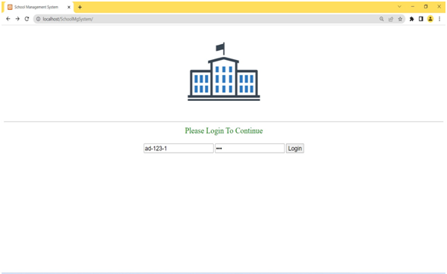

Admin Portal

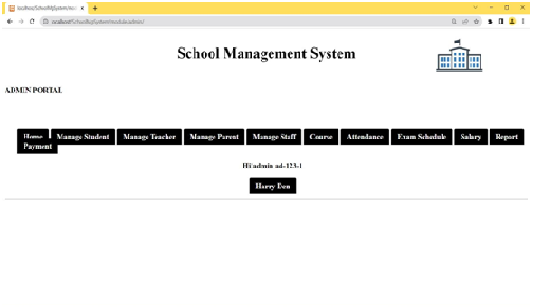

## Student Registration

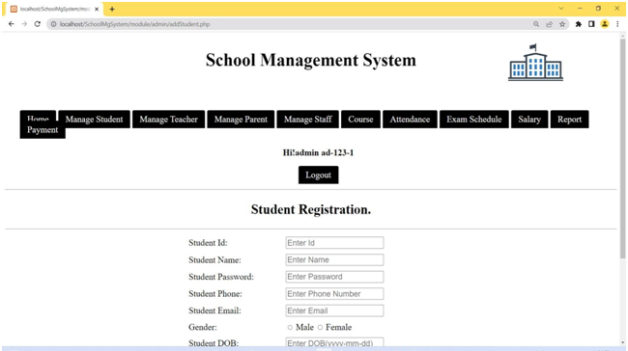

**Teacher Registration**

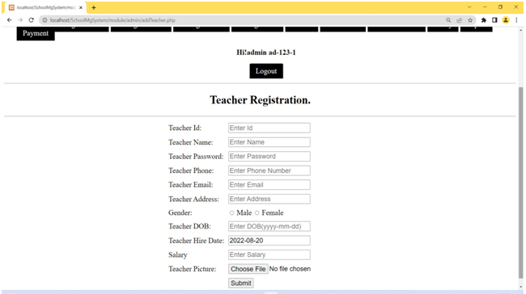

## Parent Registration

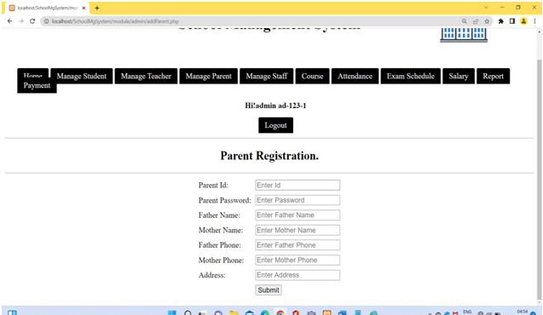

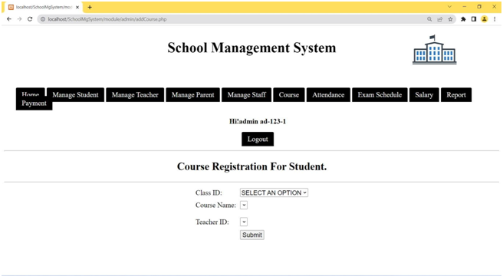

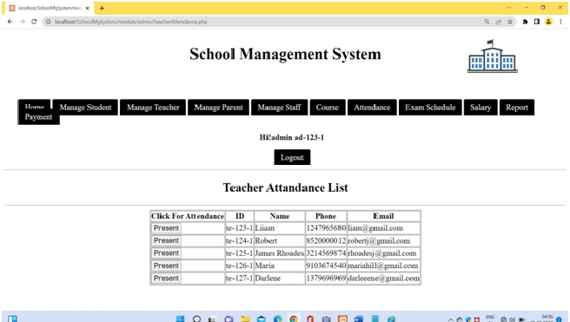

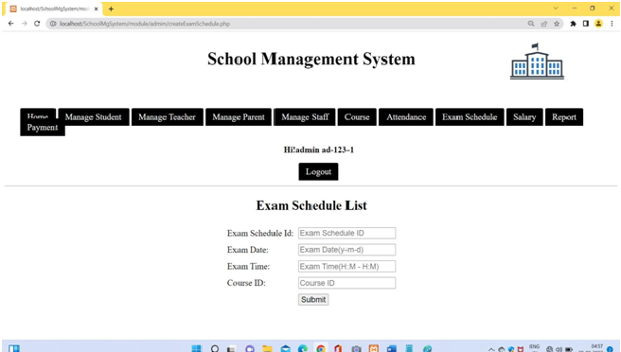



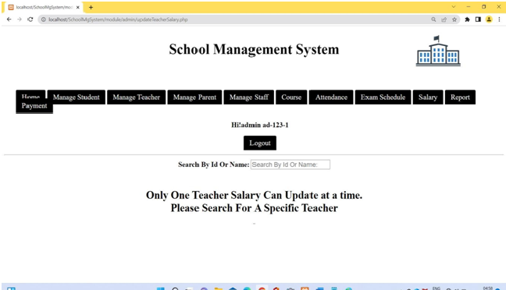

## CHAPTER 11 REFERENCE

* 1. **Web Reference**

1. [https://www.encyclopedia.com/management/encyclopedias-almanacs-transcripts-and-](https://www.encyclopedia.com/management/encyclopedias-almanacs-transcripts-and-maps/web-management) [maps/web-management](https://www.encyclopedia.com/management/encyclopedias-almanacs-transcripts-and-maps/web-management).
2. <https://www.pcmag.com/encyclopedia/term/website-management>
3. <https://www.tutsmake.com/login-and-registration-form-in-php-mysql-using-xampp/>
4. <https://www.javatpoint.com/creating-login-page-using-xampp>
5. <https://phdtalks.org/2021/03/create-dynamic-website-using-php.html>

## Book Reference

1. [**PHP & MySQL Novice to Ninja**](http://geni.us/0zwN)

## Author -Tom Butler & Kevin Yank , Latest Edition – Sixth Editionn

**,Publisher** – **Site Point**

1. [**Murach’s PHP and MySQL**](http://geni.us/PCIU9)

**Author –** Joel Murach & Ray Harris , **Latest Edition –** Third Edition,

**Publisher –** Mike Murach & Associates Inc.